**TASK 20 OUTPUT:**

**1.Selecting the date from Datepicker**

**STEPS PERFORMED ARE:**

1.Opened the chrome browser

2.Navigated to https://jqueryui.com/datepicker/

3.Maximised the browser window.

4.Switched to the frame

5.Locators are used to select the date.

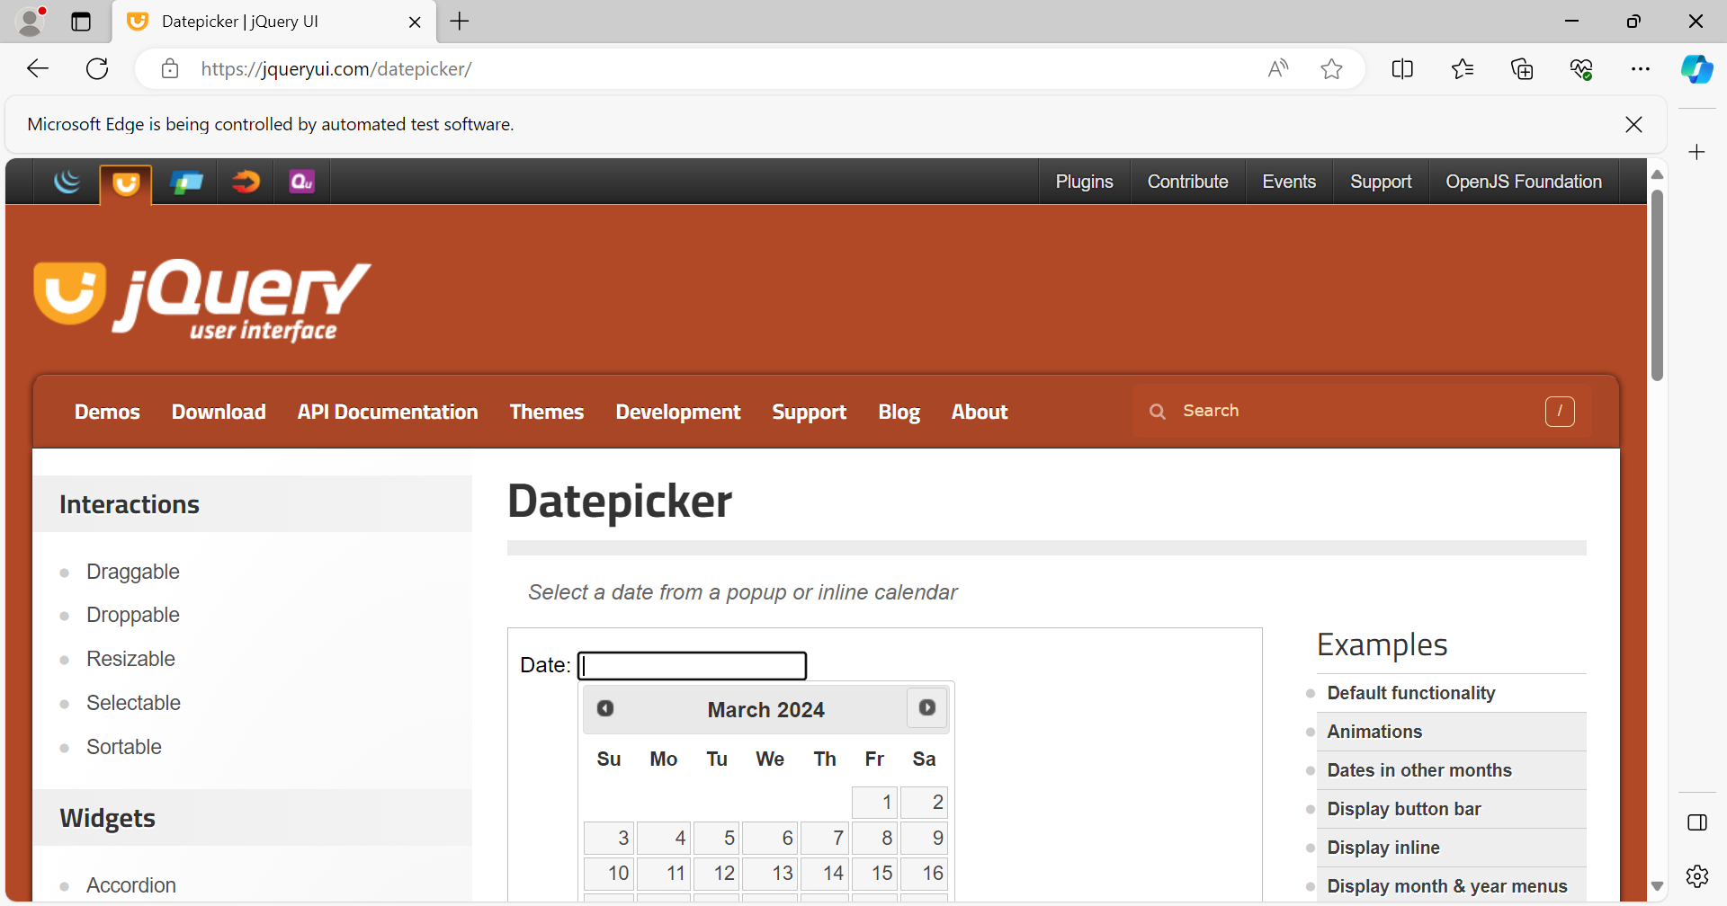

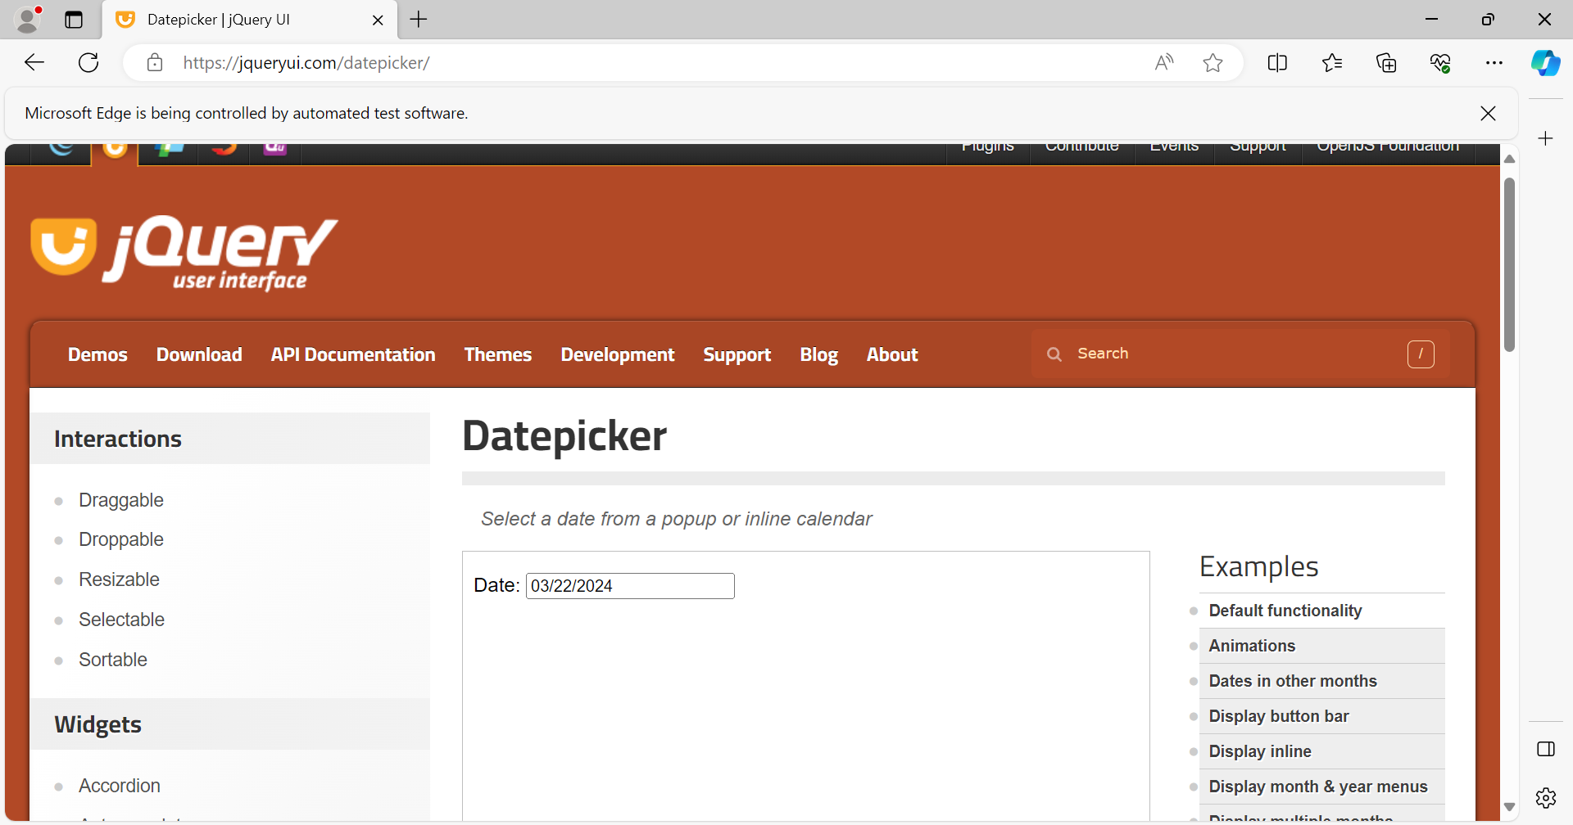

6.Browser is quitted.

7.Finally the date is printed on the console.

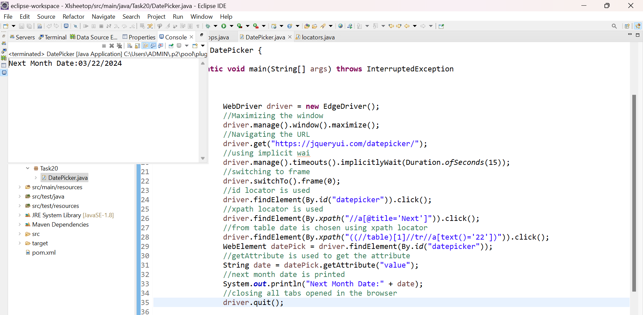

**2. Automating signup process for guvi**

**STEPS PERFORMED ARE:**

1.Opened the chrome browser

2.Navigated to <https://www.guvi.in/>

3.Maximised the browser window.

4.Details in the form are filled using the locators.

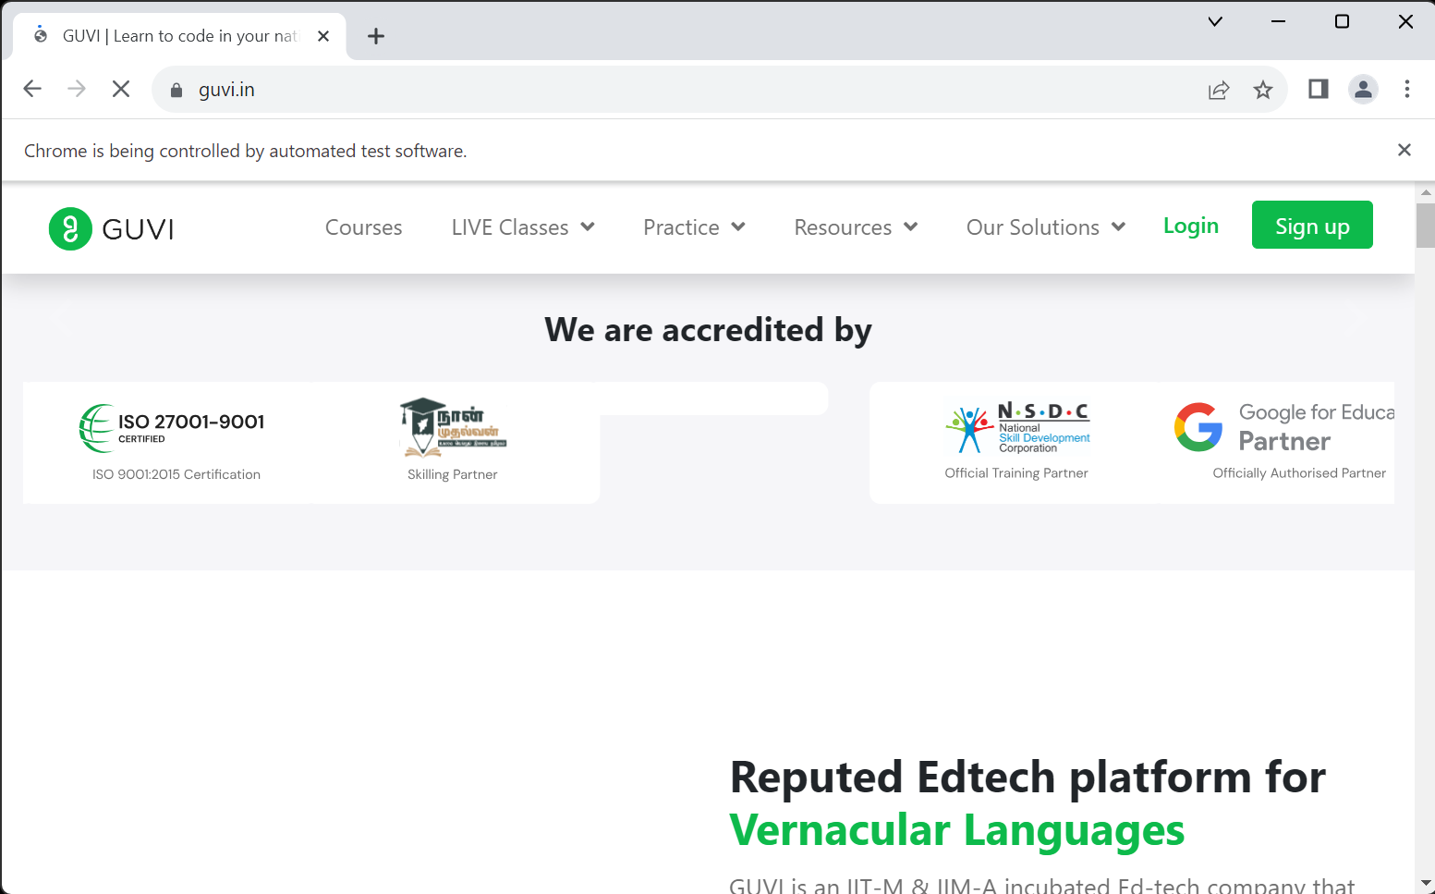

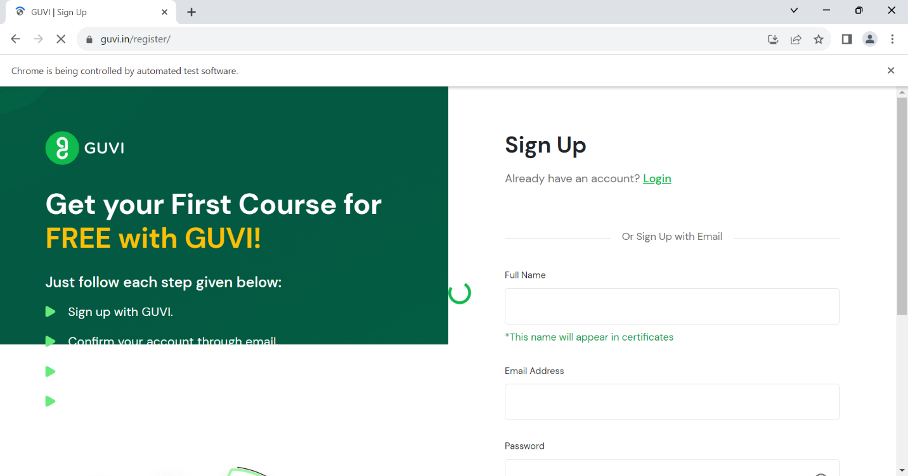

Sign up is done.

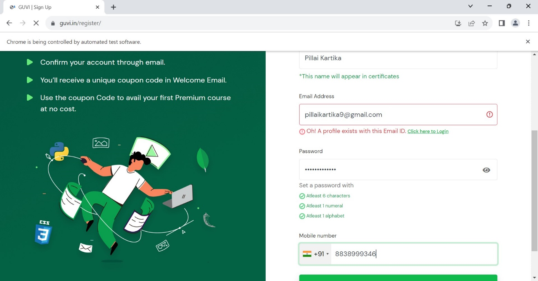

**2. Automating login process for guvi**

**STEPS PERFORMED ARE:**

1.Opened the chrome browser

2.Navigated to <https://www.guvi.in/>

3.Maximised the browser window.

4.Details in the form are filled using the locators.

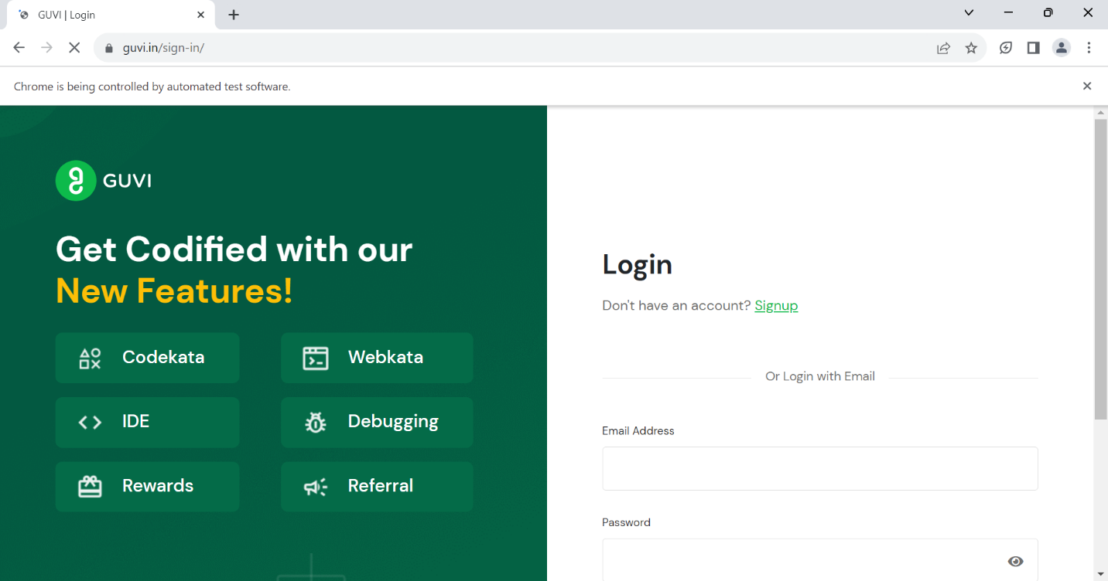

Login is done succesfully and printed on the console.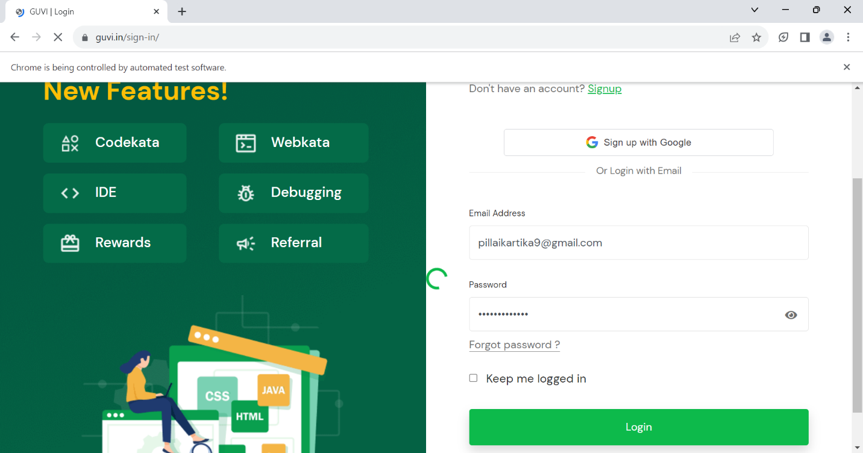

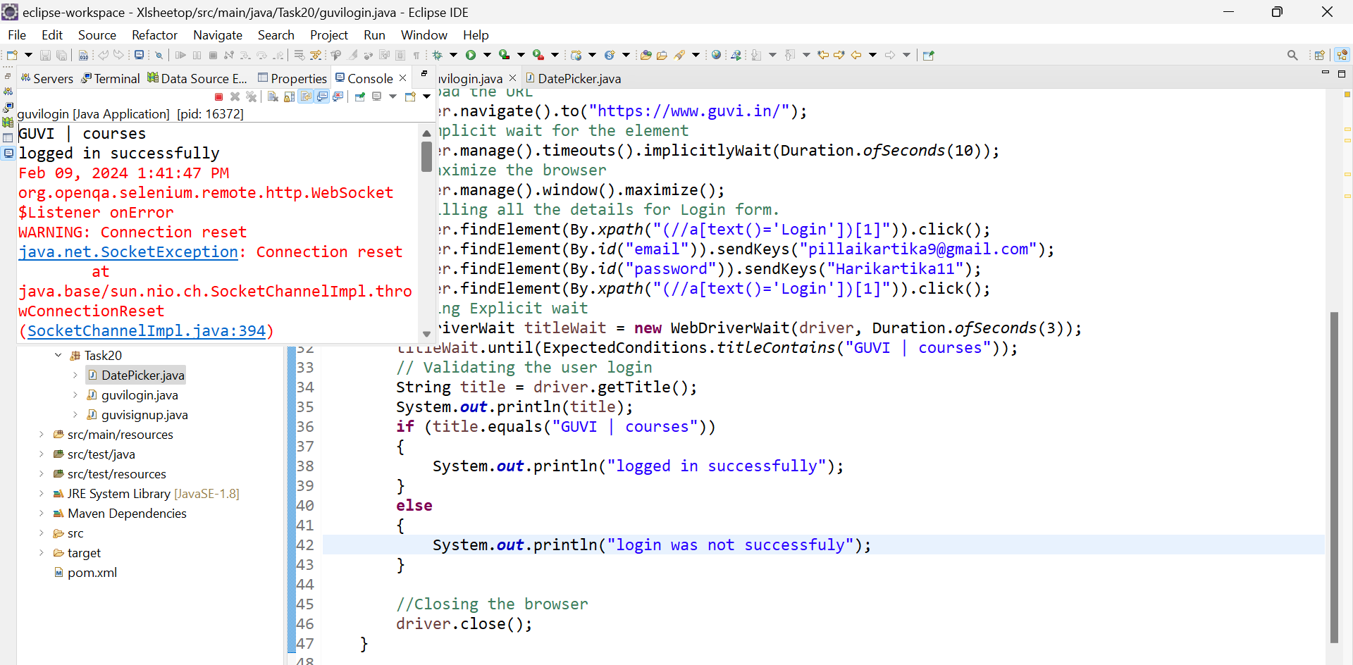

5.Linktext is used to click on submit button.

6.Sign up is done successfully.

7.Browser is closed.

6.Item is added to cart.